**Experiment-10 Study of OSPF and RIP**

ECP316 (Communication Networks)

**Aim:** To study the RIP and OSPF protocols for packet transfer in Netsim.

**Tools Used:** NetSim

**Theory:**

**RIP (Routing Information Protocol)** is a simple, distance-vector routing protocol that uses hop count as its metric to determine the best path to a destination, with a maximum hop limit of 15.

It sends routing updates periodically every 30 seconds, which can lead to slower convergence and inefficient use of bandwidth. RIP is easy to configure and works well in small networks but lacks scalability and has limited support for modem networking features like VLSM (only in RIP v2).

**OSPF (Open Shortest Path First)** is a more advanced, link-state routing protocol that uses the Shortest Path First (SPF) algorithm to calculate the best path based on link cost, which is influenced by bandwidth. Unlike RIP, OSPF sends updates only when there are topology changes, allowing it to converge quickly.

OSPF is highly scalable, supports large networks with hierarchical areas, and offers full support for VLSM and CIDR, making it ideal for complex enterprise environments.

**Procedure:**

1. Create a network on the Netsim platform,

2. For RIP: change the mode in the router to RIP and then check the packet transfer from one pc to another pc,

3. For OSPF: change the mode in the router to OSPF and initialize the weights for each path, and then check the path transfer.

**Connections:**

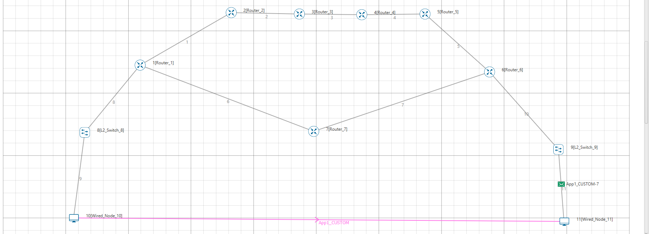

**OSPF:**

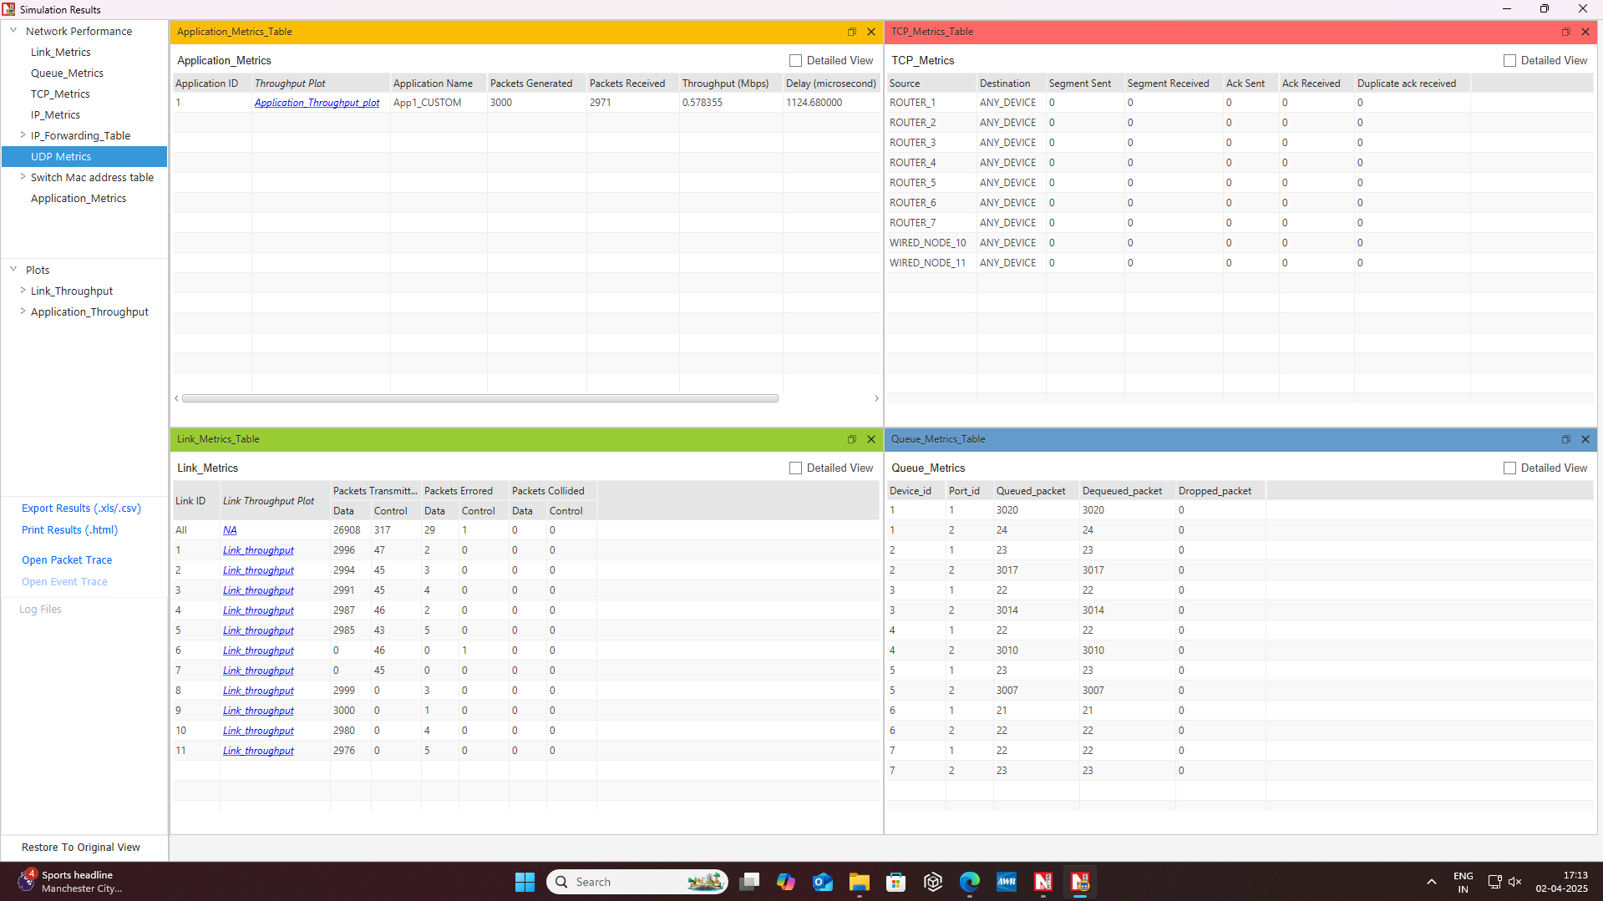

**RIP:**

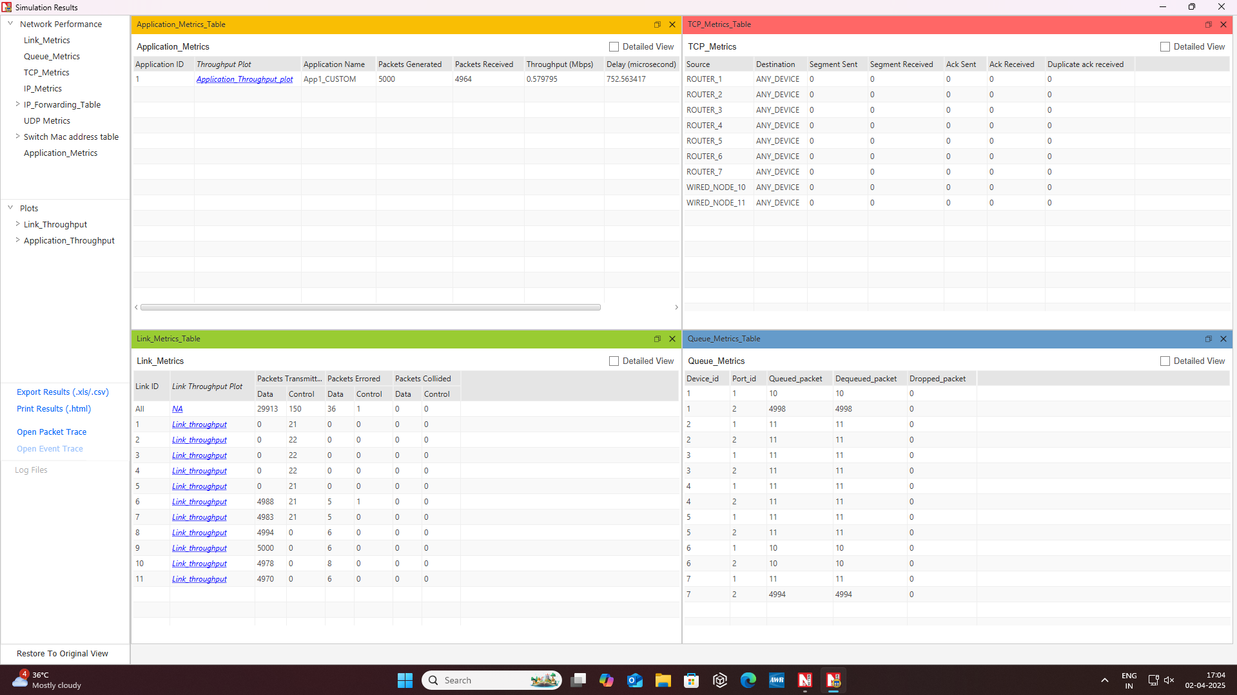

**Result:**

Using NetSim, we analyzed RIP and OSPF performance while simultaneously utilizing TCP and UDP at the application and transport layers. OSPF exhibited faster convergence and better bandwidth efficiency, while RIP suffered from delays due to periodic updates.

TCP ensures reliable data delivery, whereas UDP provides lower latency but lacks reliability.

### **Conclusion:**

1. **OSPF is more efficient than RIP** – Faster convergence and lower bandwidth consumption make OSPF suitable for large networks.
2. **TCP ensures reliability, UDP minimizes delay** – TCP guarantees data integrity, whereas UDP offers lower latency but no retransmission. TCP checks with acknowledgement while UDP doesn’t.
3. **RIP struggles with scalability** – Frequent updates and a 15-hop limit make RIP inefficient for larger networks compared to OSPF.